Investigation 13A: Weather Instruments and Observations

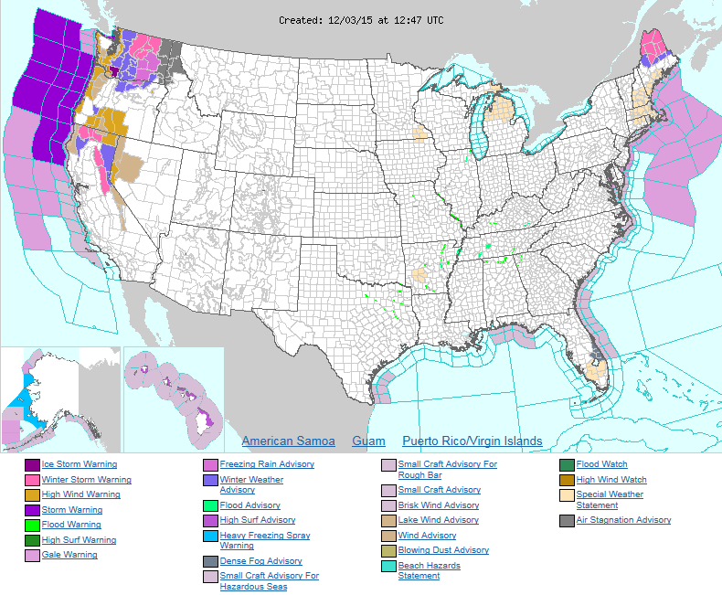
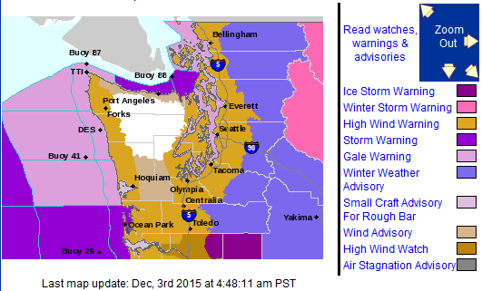
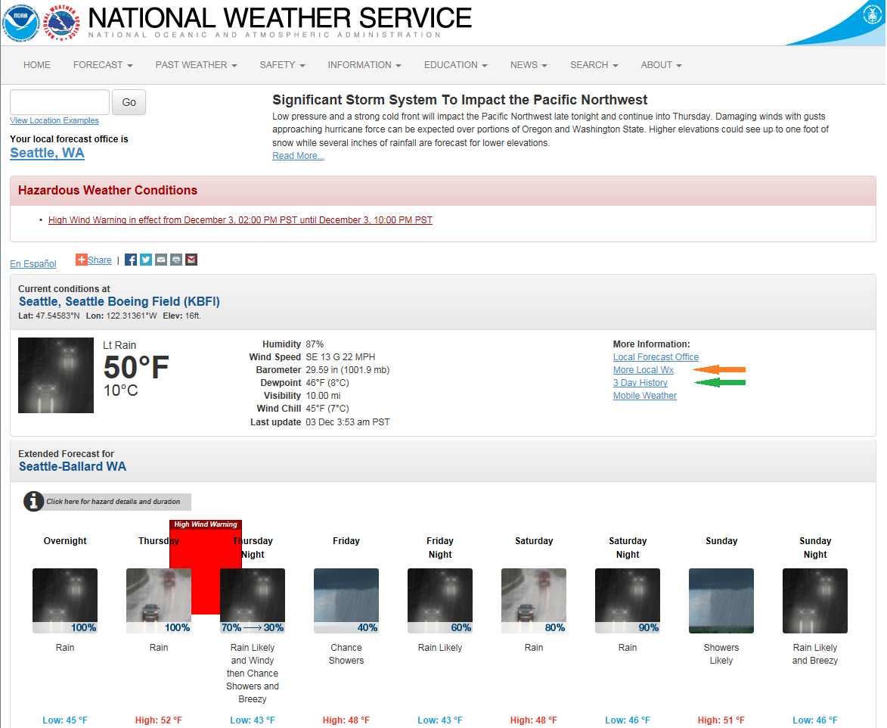

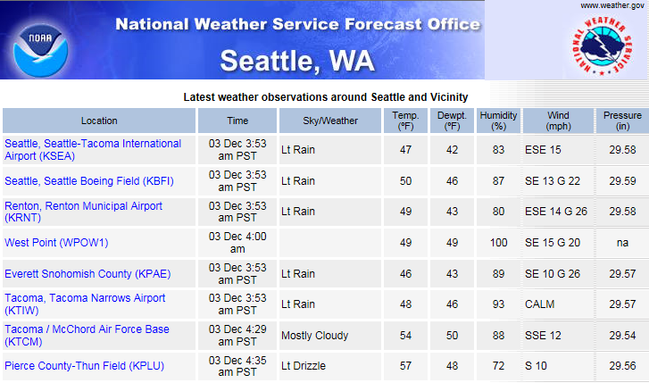

1. "Which of the weather parameters listed below is not reported in the regional observations shown in Table 1? ________."
- temperature
- dewpoint
- wind
- ceiling
- pressure

2. "This relationship can be seen with the help of Table 1. Because the relative humidity would be 100% if the temperature and dewpoint were the same, the data in Table 1 infers that the greater the difference in temperature and dewpoint, the ________ the relative humidity."
- lower
- higher

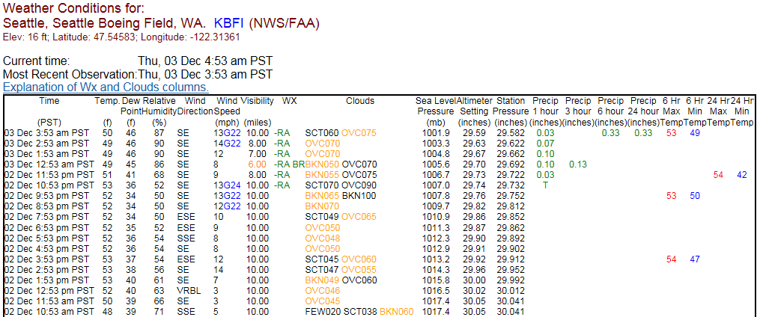

3. "Comparing the regional values from Table 1 for Seattle Boeing Field with Table 2 of only the Boeing Field values from each hour for 3 days, shows the same weather parameters below are reported in both tables except: ________."
- visibility
- wind speed and direction
- temperature and dewpoint
- relative humidity

4. "From the portion of the Table 2Temp. values listed, the highest temperature reported for Seattle Boeing Field was ________ °F."
- 48
- 53
- 59
- 61

5. "The lowest dewpoint during the hourly observations shown in the table was ________ °F."
- 34
- 42
- 46
- 51

6. "During the period shown, the maximum sea level pressure was ________ mb."
- 1001.7
- 1011.5
- 1017.4

7. "The “Clouds” condition of the hourly observations showed that the amount of sky covered by clouds generally ________."
- decreased
- remained the same
- increased

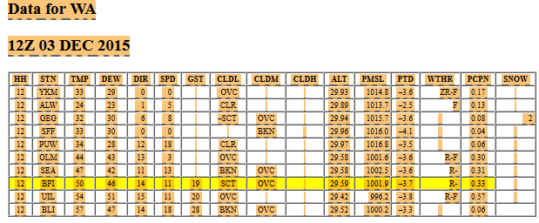

8. "Note that the two reports do not report all the same weather conditions. One condition not listed in both reports is ________."
- wind speed
- relative humidity
- dewpoint

Applications

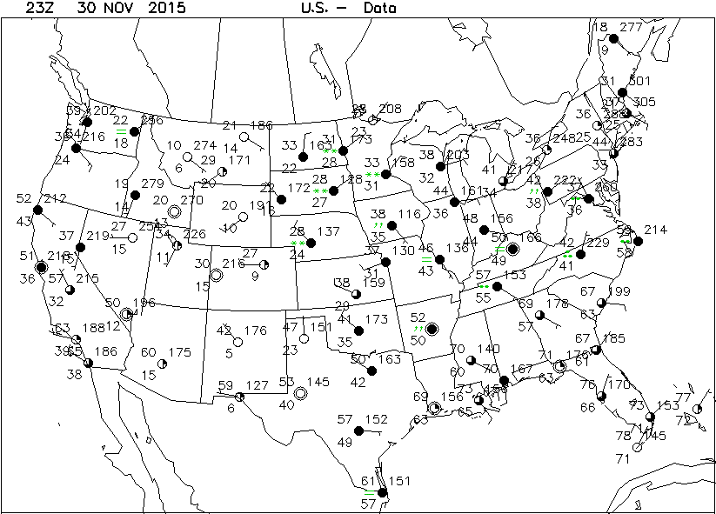

9. "The temperature at Des Moines, Iowa, at map time was ________ °F."
- 38
- 46
- 50

10. "The national map displays surface observational data from a sufficient number of stations to determine large-scale weather patterns and features. Temperatures reported on the Figure 5 map show that the area of the nation where the lowest temperatures prevailed was over the ________."
- West coast
- South-central
- North-central
- Southeast

11. "Figure 6 is a sample regional map, one of nine including Alaska and Hawaii, provided via the AMS RealTime Weather Portal. This map is labeled ________. This map is for the same time as the national map, Figure 5."
- Southern Plains – Data
- Northwest – Data
- Midwest – Data

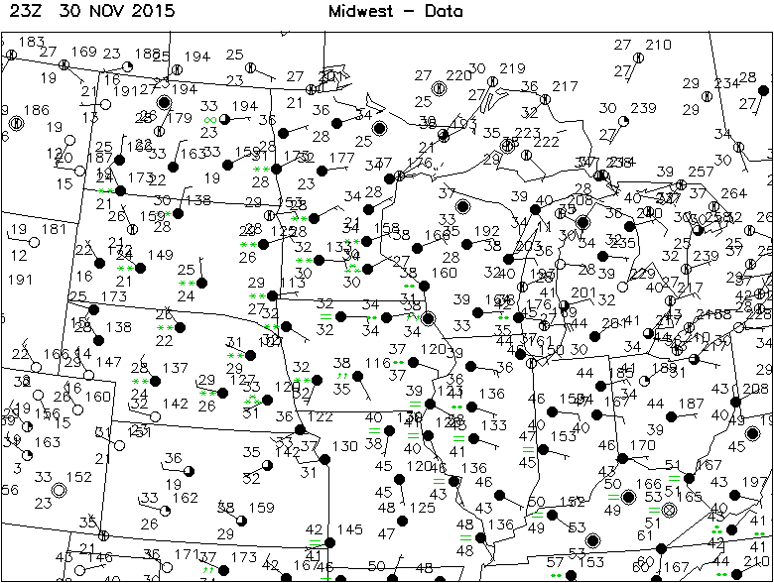

12. "The regional maps display many more stations, allowing for more detailed weather analysis. For a comparison of the station densities on the two maps, the national map has one station plotted in Iowa whereas the number of stations on the regional map in Iowa is ________."
- 4
- 8
- 13

13. "The meteogram is constructed to portray ________ hourly observations over the time period shown."
- 6
- 12
- 25

